Join the ANSE Summer University in Rotterdam!
With already more than 110 participants from all over Europe, the ANSE Summer University (21-25 August) is going to be a unique event for Coaches, Supervisors, Trainers and Counselors. This year the theme is “Moving and being moved”. During this conference week we explore the implications of the tension between security and mobility for counselling at individual, team and organisational level. With keynotes Jitske Kramer(NL), Adrienne Goehler(D), Hubert Hermans(NL) and KaupoSaue(EST) and many international workshops, it’s going to be a week full of inspiration and moving experiences. Meet colleagues from countries such as Norway, Latvia, Estonia, Ukraine and Germany. Beside you have the possibility to form International IntervisionGroups and to join a Summery Excursion in booming Rotterdam. Go cycling or take a boattrip to visit the biggest harbour of Europe!
The main language will be English. Remember that for all us English is no native language!
Programme and registration: www.SU2017.eu
--------------------------------------------------------------------------------------------------------------------------------
Note:
If you have any questions about this press release, please contact Erica Windhorst, LVSC Communications Advisor – e.windhorst@lvsc.eu or LVSC Associations Manager Caroline Emmen - c.emmen@lvsc.eu.
Below you find several logo’s and photo’s that can be used in your communication:
Logo Summer University –Moving and being moved

Photo’s for an impression of Rotterdam:
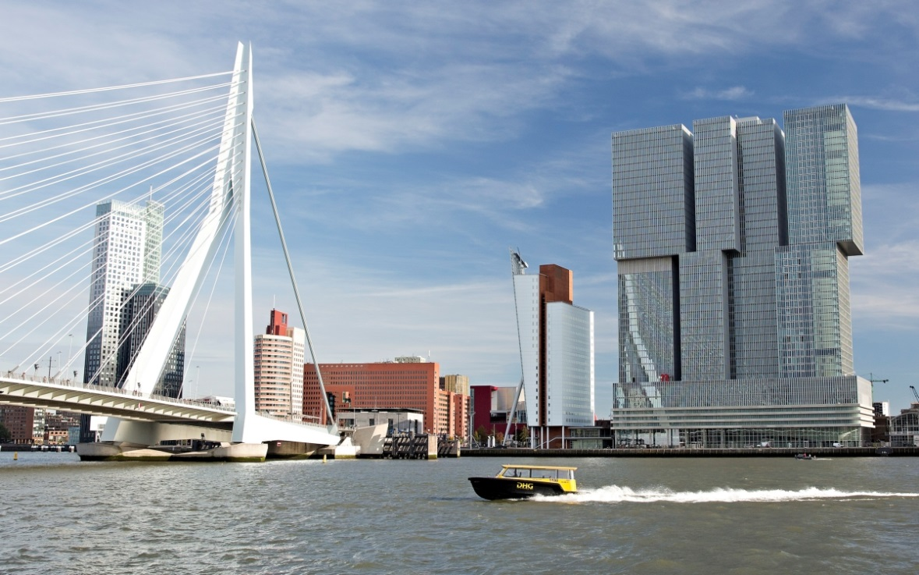
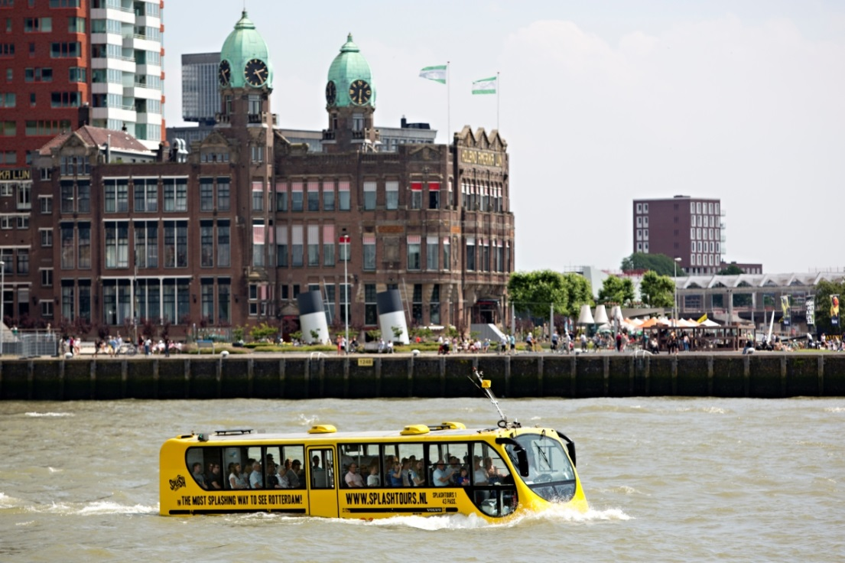
Logo’s LVSC, ANSE and Master Human and Organizational Behavior:

